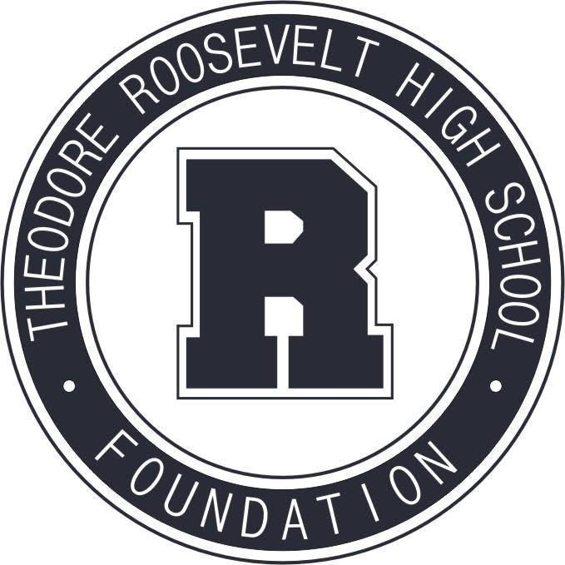

**TRHS Foundation Meeting**

**February 14, 2022**

*The Roosevelt Foundation works to celebrate Roosevelt’s history and traditions,*

*and to support Roosevelt students and faculty in their pursuit of excellence.*

1. Welcome & Call to Order
2. Approval of January Meeting Minutes
3. Treasurer’s Report
4. Principal’s Report
5. Capital Campaign Update
6. Committee Reports
   * Community Events & Fundraising – Rider Cup Prep
   * Education + Engagement - Scholarships
   * Communications & Marketing
   * Alumni Events & Relations – Hall of Fame

NEXT MEETING:

ZOOM

Monday, March 7th

5:30 p.m.

ZOOM

Monday, April 11th

5:30 p.m.