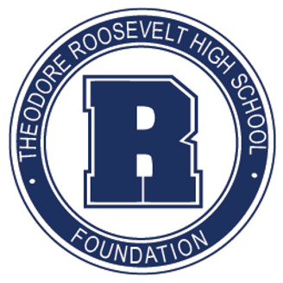

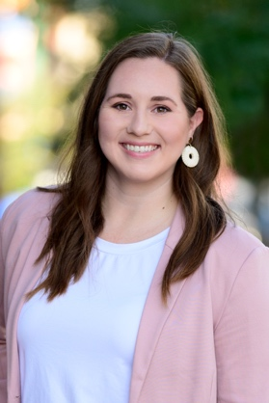
HALEIGH BIANCALANA
hmbiancalana@gmail.com

Where did you grow up?
Des Moines, IA

What college or secondary education did you attend? What is your degree or certification?
Grand View University – BA Health Promotions & Masters of Sports Management

What is your current job title and where do you work?
Director of Events – Iowa Events Center

What is your connection to Roosevelt?
2010 Graduate

What other boards or community organizations are you a part of?
Make-A-Wish Iowa

What are some skills or connections you possess that may be helpful for our board’s work?
Event management background to assist with foundation events and fundraising. Experience on other organizing committees.

What is your hidden talent?
Multi-tasking is my superpower.

What is on your bucket list?
To visit every state in the U.S.

Why did you choose to sit on the TRHS Foundation board?
To help give opportunities to students that TRHS gave to me when I was a student. Also, to continue the mission of creating a safe and healthy environment for current and future students.
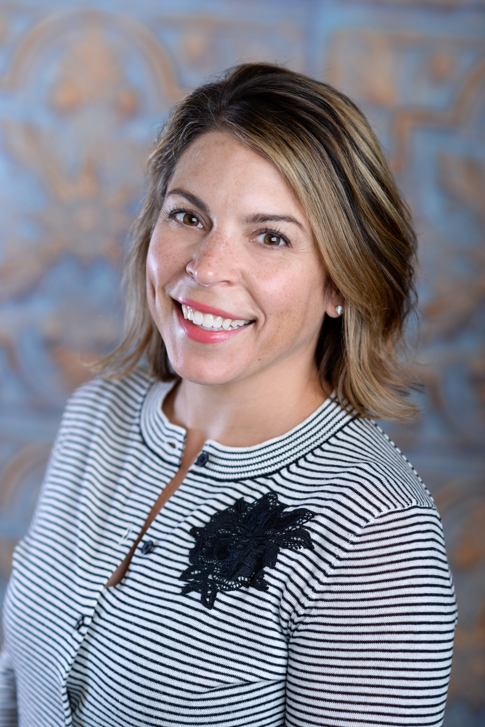

KELLY CALDBECK
kellycaldbeck@hotmail.com

Where did you grow up?
Des Moines, IA

What college or secondary education did you attend? What is your degree or certification?
Drake University – Pharmacy

What is your current job title and where do you work?
Private Pilates Instructor

What is your connection to Roosevelt?
1995 Graduate

What other boards or community organizations are you a part of?
EveryStep, Drake National Alumni Board, Delta Gamma House Corp at Drake University, DMRS.

What are some skills or connections you possess that may be helpful for our board’s work?
Fundraising, community involvement, flexible time.

What is your hidden talent?
Usually, I would say synchronized swimming, but that’s not so unique around here!

What is on your bucket list?
A safari

Why did you choose to sit on the TRHS Foundation board?
Because I had an incredible experience at TRHS and believe in the importance of the school in our community.

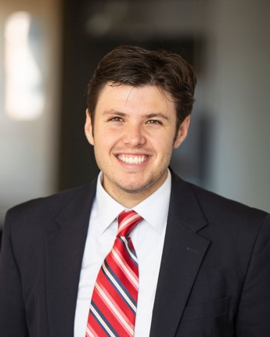

JACK CHRISTENSEN
jackbchristensen@gmail.com

Where did you grow up?
Des Moines, IA

What college or secondary education did you attend? What is your degree or certification?
Iowa State University

What is your current job title and where do you work?
Fixed Income Consultant – Charles Schwab

What is your connection to Roosevelt?
2015 Graduate

What other boards or community organizations are you a part of?
NA

What are some skills or connections you possess that may be helpful for our board’s work?
Connected with businesses around the metro. Played golf and helped set up events at Waveland when I worked there.

What is your hidden talent?
Being social.

What is on your bucket list?
Hike in Alaska

Why did you choose to sit on the TRHS Foundation board?
I wanted to get involved in my community at a young age and see a difference being made.

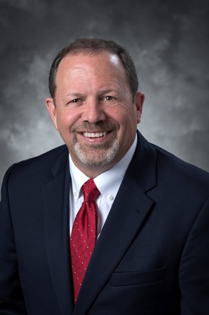

DAVE DYKSTRA
davelouisa@msn.com

Where did you grow up?
North Central Iowa

What college or secondary education did you attend? What is your degree or certification?
Central College – BA Communications

What is your current job title and where do you work?
Financial Advisor – Corebridge Financial

What is your connection to Roosevelt?
I currently have a daughter that is a junior, also have a son that was in the graduating class of 2022.

What other boards or community organizations are you a part of?
None at this time.

What are some skills or connections you possess that may be helpful for our board’s work?
I am not afraid to pick up the phone to call alumni and tell the Roosevelt Foundation story.

What is your hidden talent?
I enjoy restoring classic cars. Currently restoring a 1969 Mercury Cougar.

What is on your bucket list?
Qualifying to show a car at the Muscle Car and Corvette National Show.

Why did you choose to sit on the TRHS Foundation board?
To help Roosevelt students have the same level of resources available as other students in the surrounding districts.

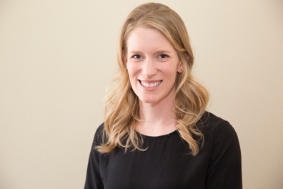

MARIE GERNES
mgernes@gmail.com

Where did you grow up?
Des Moines, IA

What college or secondary education did you attend? What is your degree or certification?
University of Iowa – BA
Delta State University (go Fighting Okra!) – MA in Education
University of Iowa – Ph.D. in Teaching & Learning

What is your current job title and where do you work?
Adjunct Instructor for The University of Iowa, College of Education

What is your connection to Roosevelt?
Alum, neighbor, future parent.

What other boards or community organizations are you a part of?
Hubbell PTA, Waterbury Neighborhood Board

What are some skills or connections you possess that may be helpful for our board’s work?
Happy to help with writing, design, editing, project planning.

What is your hidden talent?
Not really hidden with all the R Party’s bakers but… baking.

What is on your bucket list?
A hiking trip to New Zealand

Why did you choose to sit on the TRHS Foundation board?
To contribute to community support for strong public schools in Des Moines.

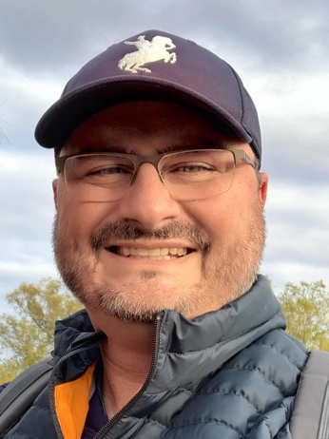

BRYAN HUGGINS
Bryan.huggins@trhsfoundation.org

Where did you grow up?
Oahu, HI / Springfield, VA

What college or secondary education did you attend? What is your degree or certification?
Oklahoma State University
What is your current job title and where do you work?
Senior Architect, BBS Architects / Engineers
What is your connection to Roosevelt?
Our twins, Isabelle and Finn, are sophomores, Class of 2025; Our youngest, Isla, will be Class of 2031.

What other boards or community organizations are you a part of?
Lead DSM

What are some skills or connections you possess that may be helpful for our board’s work?
Design, graphics, construction process, strategic planning, dad jokes.

What is your hidden talent?
I play guitar.

What is on your bucket list?
Travel to New Zealand and Iceland.

Why did you choose to sit on the TRHS Foundation board?
Once I learned about the foundation’s work, I wanted to help students and staff fully realize the potential of their TRHS experience.

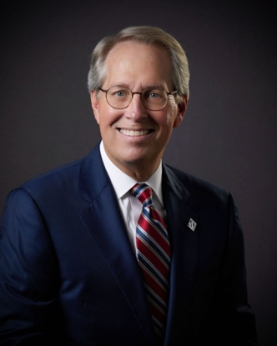

AJ JOHNSON
Aj.johnson@mediacombb.net

Where did you grow up?
Des Moines, IA

What college or secondary education did you attend? What is your degree or certification?
Wartburg College – BA; Drake University - MPA

What is your current job title and where do you work?
City Manager, City of Urbandale

What is your connection to Roosevelt?
1975 graduate

What other boards or community organizations are you a part of?
None at this time.

What are some skills or connections you possess that may be helpful for our board’s work?
Spending a career in the public sector has taught me the value of collaboration to accomplish a desired goal.

What is your hidden talent?
I am very good at listening and sorting out those items that are important to address.

What is on your bucket list?
To travel more.

Why did you choose to sit on the TRHS Foundation board?
As an alumnus, the Roosevelt experience was a key part of preparing me to move forward. I would like to assist in providing that same experience for current and future students.

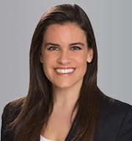

CHARLOTTE LOZIER
charlottelozier@gmail.com

Where did you grow up?
Des Moines, IA

What college or secondary education did you attend? What is your degree or certification?
Northwestern University – Majored in Communications, Minor Business Institutions

What is your current job title and where do you work?
Kathleen Stahl Travel

What is your connection to Roosevelt?
1998 graduate. Also, my father, mother, sister, and many uncles, aunts, and cousins attended.

What other boards or community organizations are you a part of?
Secretary – Colonial Dames, Des Moines Borough

What are some skills or connections you possess that may be helpful for our board’s work?
Marketing, writing press releases, website editing.

What is your hidden talent?
Travel Planning.

What is on your bucket list?
African safari.

Why did you choose to sit on the TRHS Foundation board?
I 100% support the mission! To celebrate the tradition and shape the future of Roosevelt High School by advancing and supporting the students, faculty, alumni and Roosevelt community.

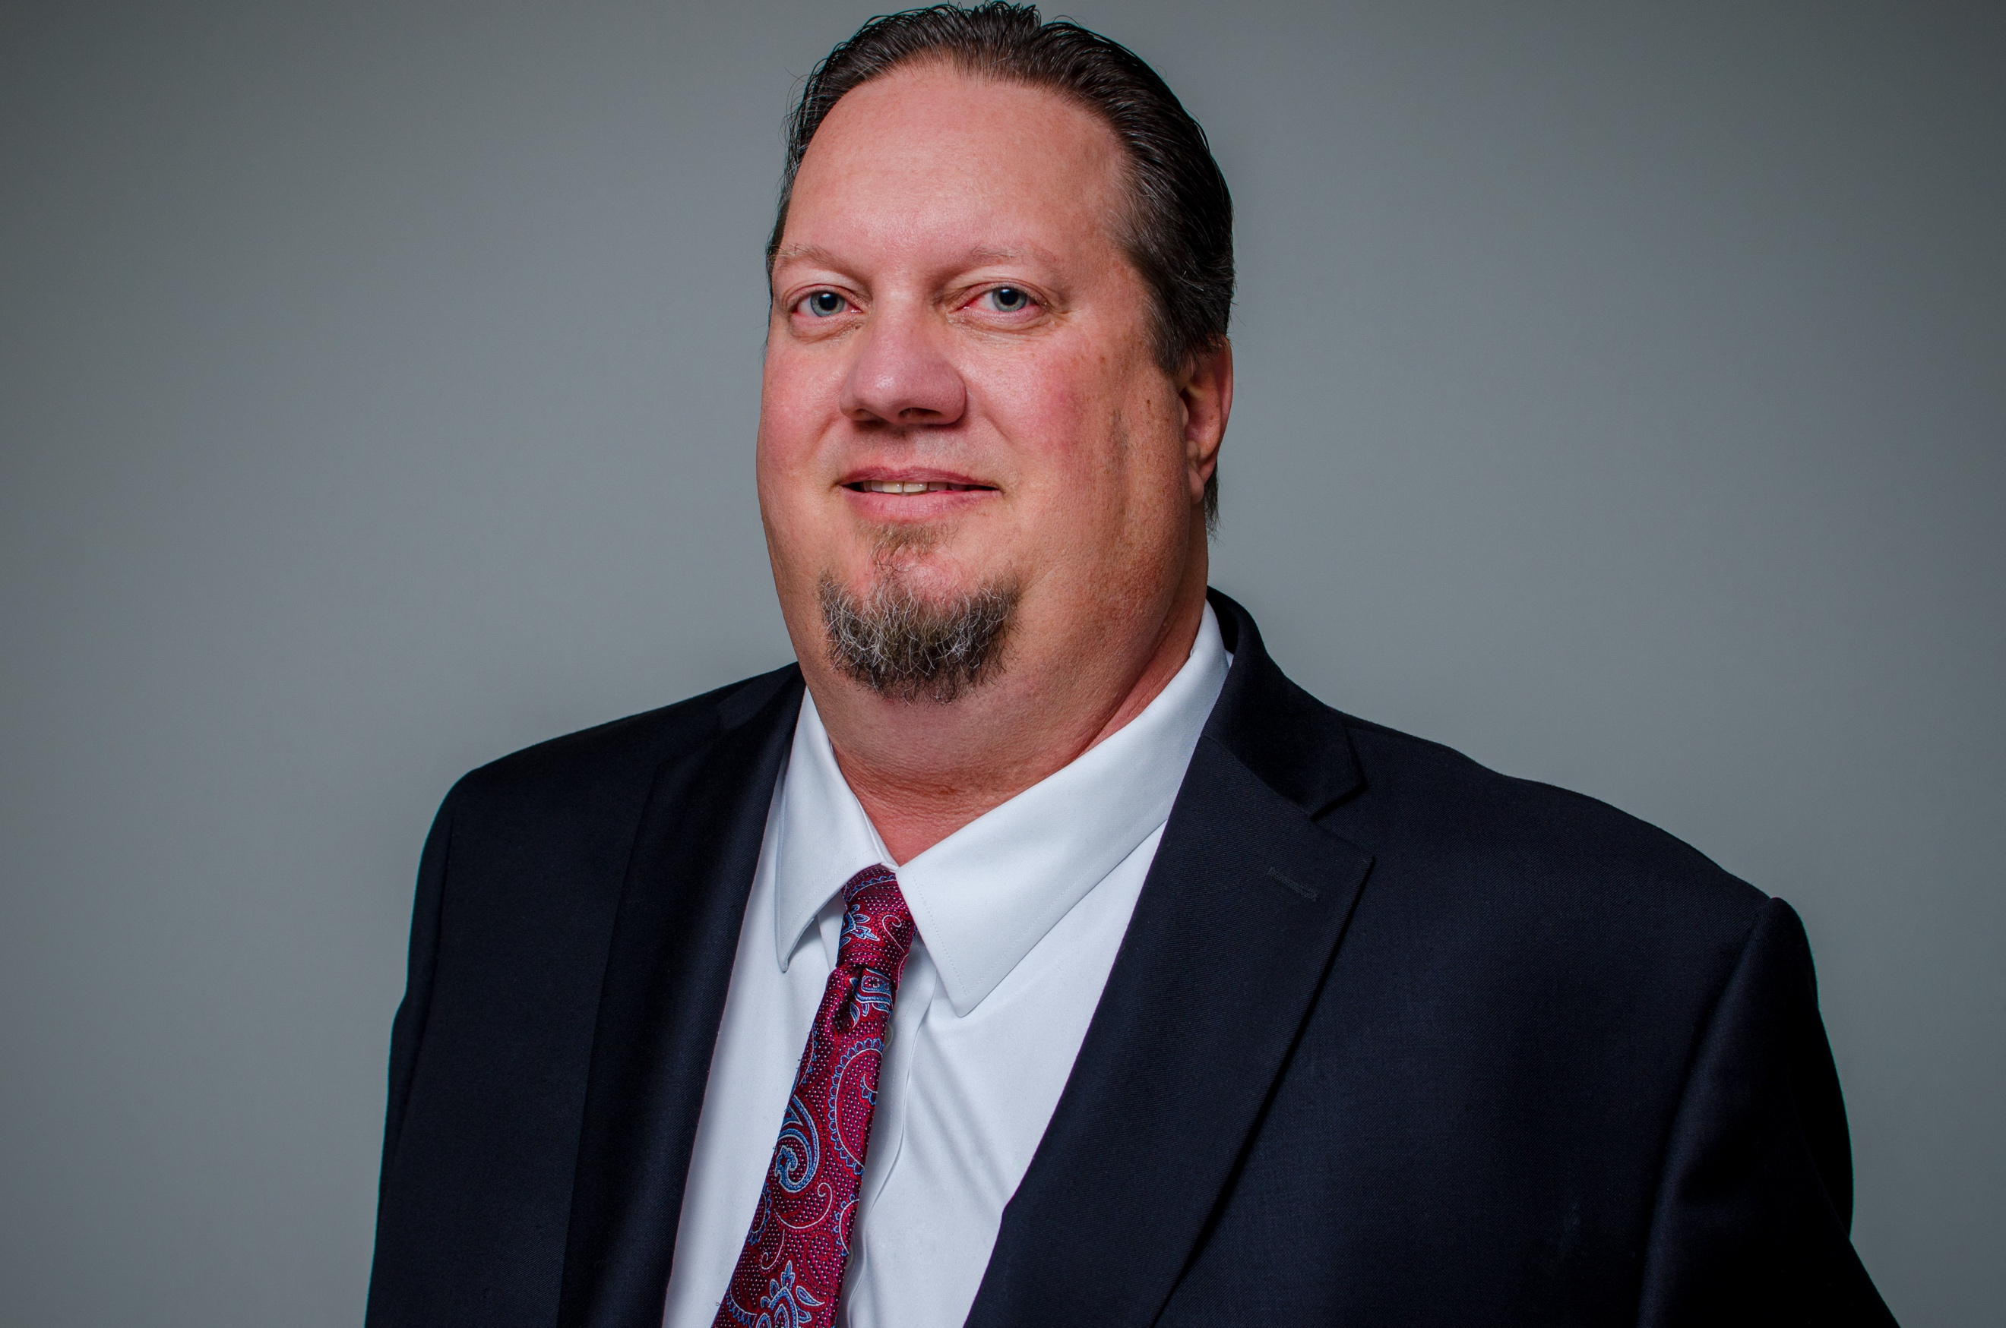

ERIK LUNDY
Tru2cy@msn.com

Where did you grow up?
Ames, IA

What college or secondary education did you attend? What is your degree or certification?
Iowa State University – Bachelor Community Regional Planning
Drake University – Masters Public Administration

What is your current job title and where do you work?
Zoning Enforcement Officer, City of Des Moines

What is your connection to Roosevelt?
Daughters and nephew are alumni, twin niece and nephew attend. My wife Carrie teaches at Perkins Elementary (a feeder school).

What other boards or community organizations are you a part of?
None at this time.

What are some skills or connections you possess that may be helpful for our board’s work?
I have worked with most businesses and developers in Des Moines proper and have connections, particularly with the developer/design consultant community.

What is your hidden talent?
I’m a Karaoke and Trivia junkie

What is on your bucket list?
New Zealand

Why did you choose to sit on the TRHS Foundation board?
When I started, I was coming off of the Northwest Soccer Board as a longtime Director of Coaches. I wanted to keep giving back to my neighborhood community and still had a daughter attending Roosevelt. I was recruited by fellow Drake alum Natalie Pohlman a contract employee of the Foundation at that time.

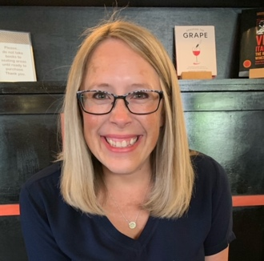
KATE MEAD
katesmead@gmail.com

Where did you grow up?
Des Moines, IA

What college or secondary education did you attend? What is your degree or certification?
St. Olaf College – BA of Psychology and Elementary Teaching Degree

What is your current job title and where do you work?
Advanced Learning Program Consultant – Des Moines Public Schools

What is your connection to Roosevelt?
I come from a family line that all went to Roosevelt. I also work for DMPS and my two girls will attend Roosevelt starting in the Fall of 2023.

What other boards or community organizations are you a part of?
I volunteer throughout the year with different organizations and support my church.

What are some skills or connections you possess that may be helpful for our board’s work?
As an educator, I am passionate about education and believe strongly in our community supporting our local schools. I am a team player and love to connect with fellow alum.

What is your hidden talent?
I make a mean scotcheroo!

What is on your bucket list?
I can’t wait to pull oysters straight from the ocean and eat them right there with a sip of champagne.

Why did you choose to sit on the TRHS Foundation board?
I want to give back to the school that gave me so much. Plus, my children will attend TRHS.

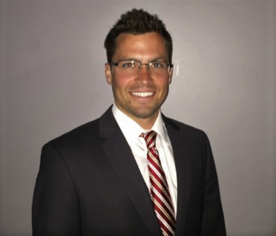

NATE NIELSEN
Nnielsen.iowa@gmail.com

Where did you grow up?
Des Moines, IA

What college or secondary education did you attend? What is your degree or certification?
University of Iowa – Finance & Management

What is your current job title and where do you work?
Mortgage Consultant – Wells Fargo

What is your connection to Roosevelt?
Alumni

What other boards or community organizations are you a part of?
None at this time.

What are some skills or connections you possess that may be helpful for our board’s work?
Skills: organization, written and verbal communication, sales. Born and raised in Des Moines, so somewhat familiar with the community and the people in it. All of which can be used for outreach.

What is your hidden talent?
Playing the tuba.

What is on your bucket list?
Visit the Egyptian pyramids.

Why did you choose to sit on the TRHS Foundation board?
The capital campaign and to have an impact on students and the Roosevelt community.

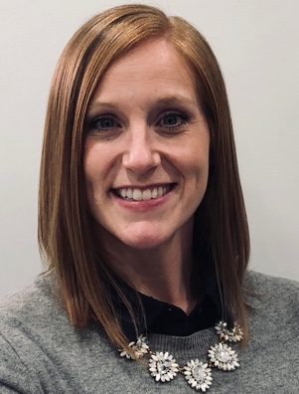

DANIELLE ROECKER
Danielle.roecker@trhsfoundation.org

Where did you grow up?
Shelby, IA

What college or secondary education did you attend? What is your degree or certification?
Iowa State University – Bachelor’s Degree Management Information Systems & Graduate Certificate in Human-Computer Interaction
Colorado Technical University – masters of business Administration

What is your current job title and where do you work?
IT Delivery Leader with Accenture (a Global Consulting firm)

What is your connection to Roosevelt?
Two children at Roosevelt: Abbie (Class of ’25) and Graham (Class of ’26)

What other boards or community organizations are you a part of?
Rider Club Softball

What are some skills or connections you possess that may be helpful for our board’s work?
I have served on a variety of educational, sports and corporate boards that have given me great perspective on engaging volunteers, working towards a vision and making progress even when funds are limited.

What is your hidden talent?
Finding basically anything on the internet.

What is on your bucket list?
Visit all 10 Wonders of the World.

Why did you choose to sit on the TRHS Foundation board?
I have a passion for helping our community and especially our educational system. The TRHS Foundation is filled with such a talented group of individuals and it is an honor to serve with them.
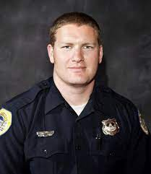

TED STROOPE
tlstroope@dmgov.org

Where did you grow up?
Des Moines, IA

What college or secondary education did you attend? What is your degree or certification?
Kansas State University – BS Construction Science and Management
Iowa State University – MCRP Community and Regional Planning
What is your current job title and where do you work?
Lieutenant – Des Moines Police Department
What is your connection to Roosevelt?
1999 Alumni; Two children in the feeder system.

What other boards or community organizations are you a part of?
President of Des Moines Police Gold Braid Organization

What are some skills or connections you possess that may be helpful for our board’s work?
Project Management

What is your hidden talent?
NA

What is on your bucket list?
NA

Why did you choose to sit on the TRHS Foundation board?
To have a better school experience for my kids.

Why did you choose to sit on the TRHS Foundation board?
When I started, I was coming off of the Northwest Soccer Board as a longtime Director of Coaches. I wanted to keep giving back to my neighborhood community and still had a daughter attending Roosevelt. I was recruited by fellow Drake alum Natalie Pohlman a contract employee of the Foundation at that time.

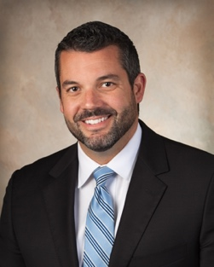

ZACH STUBBS
stubbszd@gmail.com

Where did you grow up?
Des Moines, IA

What college or secondary education did you attend? What is your degree or certification?
Westminster College - BA Business Administration

What is your current job title and where do you work?
Senior Vice President – West Bank

What is your connection to Roosevelt
2003 Graduate

What other boards or community organizations are you a part of?
Blank Children’s Hospital Board of Directors
Iowa Bankers Board of Directors
Interchange Breakfast Club

What are some skills or connections you possess that may be helpful for our board’s work?
Finance/Banking

What is your hidden talent?
Pilot 11+ years – airplane owner

What is on your bucket list?
Sail around the Bahamas

Why did you choose to sit on the TRHS Foundation board?
Roosevelt shaped me into who I am today.

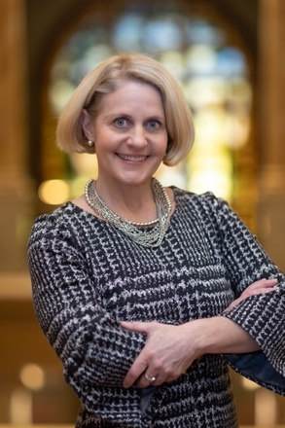

HEATHER WELCH PURI
hwpuri@gmail.com

Where did you grow up?
Des Moines, IA

What college or secondary education did you attend? What is your degree or certification?
Stanford University – BA in Quantitative Economics
Kellogg Graduate School of Management – MBA (finance and strategy emphases)

What is your current job title and where do you work?
Capital Markets – Director of Finance & Strategy at Peoples Company

What is your connection to Roosevelt?
1988 graduate; both sons attend/attended Roosevelt.

What other boards or community organizations are you a part of?
None at this time.

What are some skills or connections you possess that may be helpful for our board’s work?
Finance background, high level of attention to detail.

What is your hidden talent?
Photography

What is on your bucket list?
Travel to Spain and Southeast Asia

Why did you choose to sit on the TRHS Foundation board?
When I started, I was coming off of the Northwest Soccer Board as a longtime Director of To give back to the Roosevelt community and help provide the best resources and learning experiences for current and future TRHS students.

