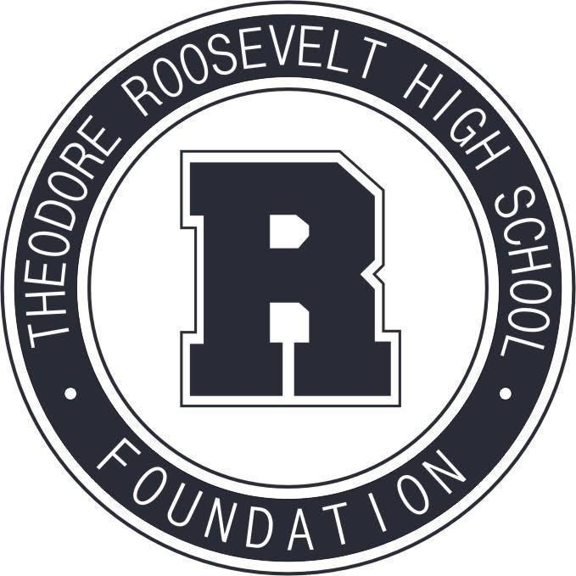

TRHS Foundation Meeting
April 12, 2021

The Roosevelt Foundation works to celebrate Roosevelt’s history and traditions,
and to support Roosevelt current students and faculty.

- Welcome & Call to Order

- Guests
  - Nicole Crawford, TRHS, Special Request
  - Rebecca Coady, Business Horizons, Special Request
  - “Roosevelt for the Generations” Campaign Consultants + Chairs
    - Connie Isaacson, Isaacson Syverson, Fundraising Consultant
    - Jackie Norris, Co-Chair, Roosevelt Parent
    - Laura Leonard, Co-Chair, Roosevelt Alumni
    - Brian, Gentry, Co-Chair, Roosevelt Parent

- Approval of March Meeting Minutes

- Treasurer's Report

- Principal’s Report

- Committee Reports
Community Events + Fundraising
Alumni Relations + Events
Communications + Marketing
Education + Engagement (formerly Scholarships + Grants Committee)
Capital Campaign
Review Calendar: Committee Activities through Summer 2021

